**Project Documentation**

Outline :

//Project and Developer details

//Sprints planned and Tasks achieved

//Algorithms and Flowcharts

//Core concepts

//Github Repository Link

//Conclusion

**Project and Developer Details :**

* Project Details :-

                     The main purpose of this project is to create a simple calculator which can perform basic arithmetic operations like addition, subtraction, multiplication or division depending upon the user input.

* Developer Details :-
* Shubham Phulchand Gupta

**Sprints Planned and Tasks achieved :**

* STS Planning
* Tasks achieved:
* Addition of two numbers
* Subtraction of two numbers
* Multiplication of two numbers
* Division of two numbers

Algorithms and Flowcharts :-

Algorithm :-

**1 Step:** BEGIN.

**2 Step:** PRINT ENTER YOUR CHOICE.

**3 Step:** ENTER YOUR CHOICE.

**4 Step:** ENTER TWO OPERANDS FOR OPERATION.

**5 Step:** USER WILL ENTER +,-,*,/ .

**6 Step:** SWITCH(OPERATOR)

**7 Step:** DO THE OPERATION.

**8 Step:** PRINT THE RESULT.

**8 Step:** EXIT.

Flowchart:-

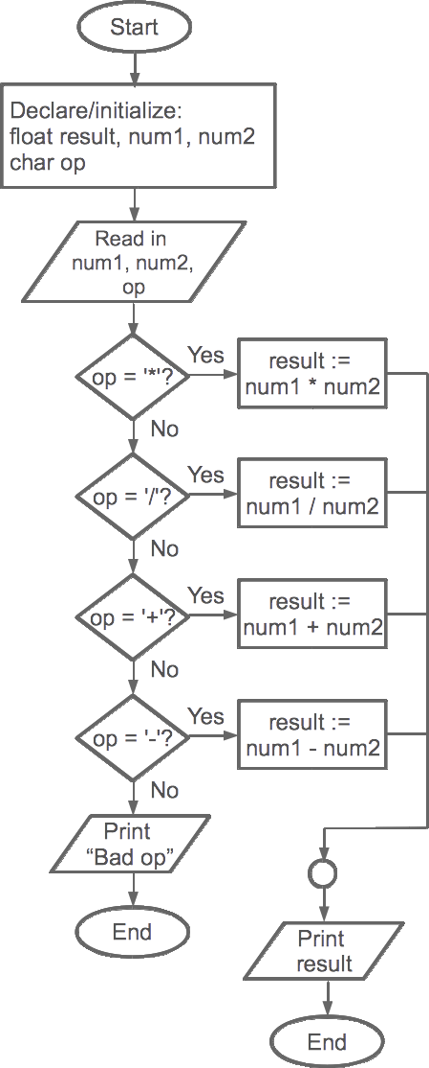

**Core Concept** :

  We have used the class, packages, while, switch, string,. Firstly we have created a package in that we have created a class. We have used while and switch condition for iteration until the Boolean function is true. Once it is true it comes out of the loop and displays the output. String class is used to create the path.

**Github Repository link** :

https://github.com/shubz77/Phase1-Assisted-Projects.git

**Conclusion** :

 In this work we have developed a calculator for exact real number computation and performed a theoretical analysis of the algorithms and experimented on their implementation.